OFFER REQUEST – IGLO LINE ver. 02/2024

Date / place:
Company name:
Contact name:
Location:
Telephone:
E-mail address: |  | Website:

Continuous freezers (in your possession) to be connected to the Iglo Line tunnel
Quantity of freezers:
Producer:
Model:
Capacity:
Year of production:
Remarks:

OFFER REQUEST FOR:
FROSTO - continuous freezer
Capacity l/h quantity pcs
For what kind of packaging machines (capacity of the packaging machines,
volume of packaging/type/-s of the final products)

 | IGLO - LINE - automatic extruding and hardening tunnel
No. | Products: |  |  |  | Max. product height |  | Max. product width |  | Capacity  (pieces/  hour)
1. |  | stick ice cream (“magnum” type)  volume ml  description  required capacity pcs/h | 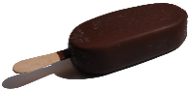
2. |  | stick ice cream (solero type)  volume ml  description  required capacity pcs/h | 
3. |  | stick ice cream (magnum double type)  volume ml  description  required capacity pcs/h | 

3. |  | stick ice cream (multicolor chocolate)  volume ml description  required capacity pcs/h | 
4. |  | stick ice cream (dry coating) - volume ml  description  required capacity pcs/h | 
5. |  | stick ice cream (“funny face” type)  volume ml  description  required capacity pcs/h | 
6. |  | ball-top cone  volume ml  description  required capacity pcs/h | 
7. |  | GIANT type cone – no chocolate coating  volume ml  description  required capacity pcs/h | 
8. |  | wafer cup  volume ml  description  required capacity pcs/h | 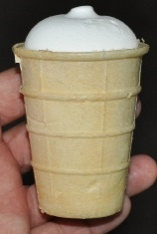
9. |  | “twister” type horizontally extruded  volume ml  description  required capacity pcs/h | 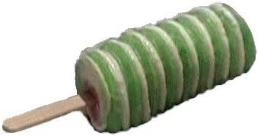
10. |  | “mini-vienetta” type horizontally extruded –  volume ml  description  required capacity pcs/h | 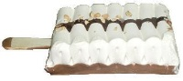
11. |  | Sandwich standard  volume ml  description  required capacity pcs/h | 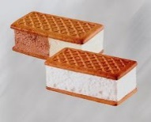
12. |  | Round sandwich  volume ml  description  required capacity pcs/h | 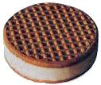
13. |  | sandwich half biscuit, half choco-coated  volume ml  description  required capacity pcs/h | 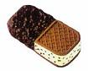
14. |  | country-style sandwich  volume ml  number of colors  sauce  inclusions | 
15. |  | sandwich “stracciatella”  volume ml  description  required capacity pcs/h | 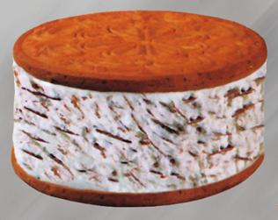
16. |  | Wafers / biscuits, placed on the chocolate coating surface  volume ml  description  required capacity pcs/h | 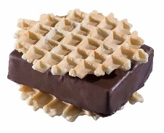  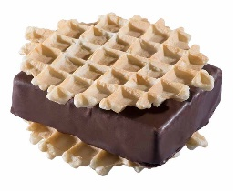  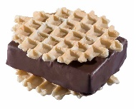
17. |  | oval sandwich totally enrobed  volume ml  description  required capacity pcs/h | 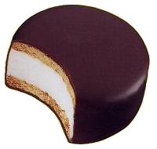
18. |  | candy bar  volume ml  description  required capacity pcs/h | 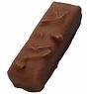
19. |  | bon-bon candy  volume ml  description  required capacity pcs/h | 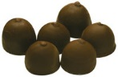
20. |  | layer cake  volume ml  description  required capacity pcs/h | 

21. |  | standard 3-color log  volume ml  description  required capacity pcs/h | 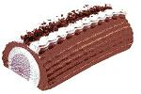
22. |  | Viennetta type log log  volume ml  description  required capacity pcs/h | 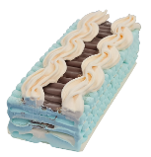
23. |  | other  (e.g. products hardened on the tunnel, but filled manually or on other machines)

ADDITIONAL REQUIREMENTS:

- Evaporator (high efficiency air cooler):
required number of working hours without the necessity
of Iglo Line defrosting
standard execution (mix of construction materials)
stainless steel execution
special construction with different sections to enable longer work without defrost
dehumidifier
frequency inverter for air fans ( one for all or separately )
other

2. Cooling agent:
ammonia (NH₃)
freon, specify type:
C0 2
other
Complete refrigeration unit or freon compressors?
Complete assembly of the refrigeration unit by ICE GROUP?

3. Insulated chamber:
Insulated polyurethane panels :
standard – galvanized steel, white painted on the inside and on the outside
stainless steel on the inside and galvanized steel, white painted on the outside
stainless steel on the inside and on the outside
Inner part of hardening chamber:
standard execution chamber (panels riveted, floor weldedstainless steel
perforated surface anti slide )
fully welded stainless steel chamber inside

4. Electronic and steering components:
Allen Bradley model/ size
Siemens model/size
Additional control box with 10” touch screen panel beside DIP tower
Additional control box with 10” touch screen panel near Multiline machine
other

5. Construction details, solution and components:
Gears and motoreducers:
basic, standard execution (e.g. Bonfiglioli, Motovario)
special, higher class execution (e.g. SEW, NORD)
other

Servomotors:
standard version
food-grade, white painted version
other

AC motors:
standard AB Motoren
SEW
other

Frequency inverters:
standard OMRON, MITSUBISHI ,RA
Siemens
DANFOSS
other

Pneumatic components:
FESTO
SMC
other

6. UPGRADES / SURCHARGES
Automatic stick inserters stations
Automatic system for MULTIPACK cartonning system

7. Auxiliary accessories:
chocolate melting and preparation tank capacity liters
fruit / ingredient feeder
sauce pumps / chocolate pumps
Upgrade to chocolate pump to work with chocolate with nuts
Divided chocolate tank in DIP station to work with two different chocolate colors
(with additional second chocolate pump)
300l chocolate buffer tank with pump (standard pump)
Crumbles constant feeder with conveyor for nuts
other

